**SEARCH ALGORITHMS**

**LINEAR SEARCH**

* Array need not be sorted

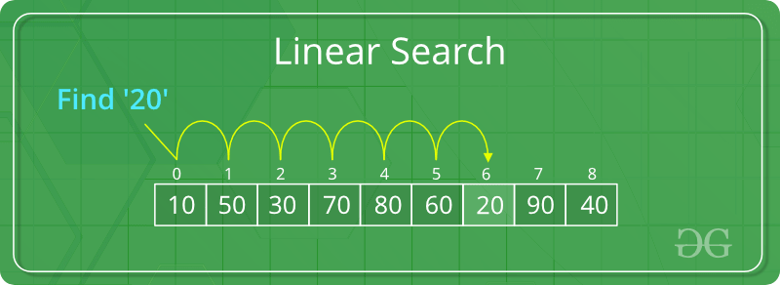

**Linear Search to find the element “20” in a given list of numbers**

**BINARY SEARCH**

* Array should be SORTED to apply binary search on it

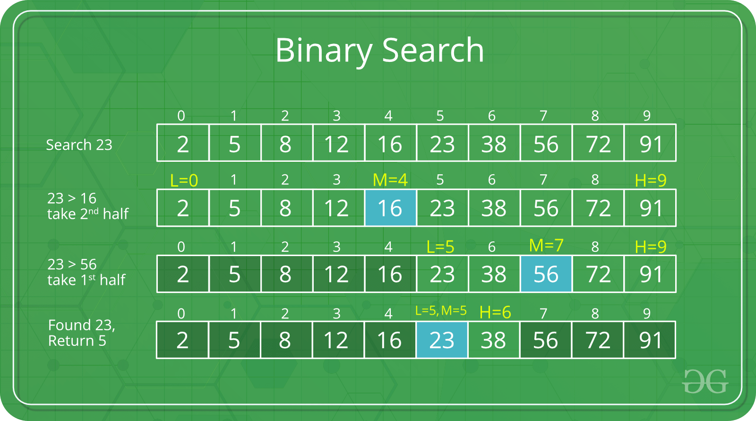

**Binary Search to find the element “23” in a given list of numbers**

**Linear Search vs Binary Search**

* Input data needs to be *sorted* in Binary Search and not in Linear Search
* Linear search does the *sequential access*; Binary search accesses *data randomly.*
* Time complexity of linear search is ***O(n)*** , Binary search - ***O(log n).***